Assignment

**Exercise 2 - Create a markdown cell with the title of the notebook. (1 pt)**

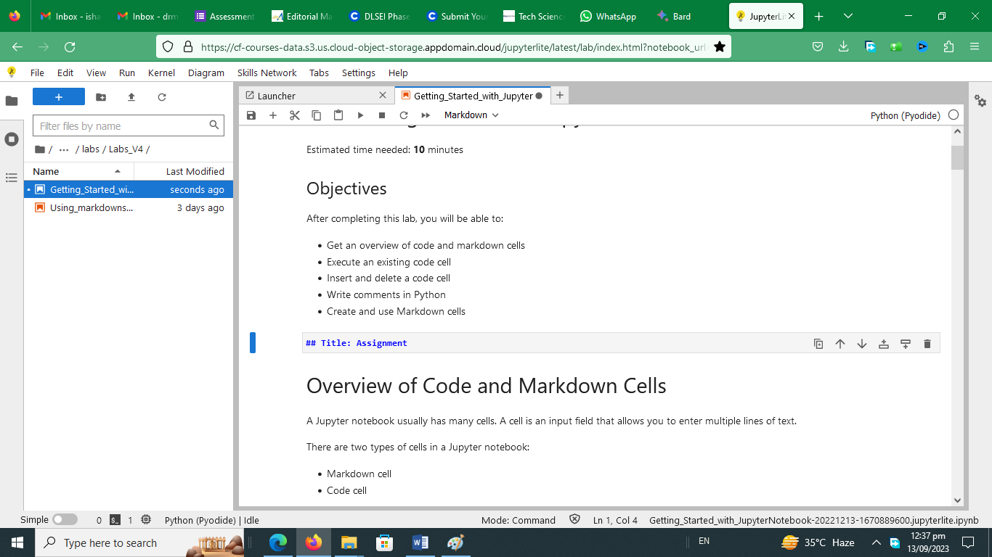

**Title: Assignment**

**Exercise 3 - Create a markdown cell for an introduction. (1 pt)**

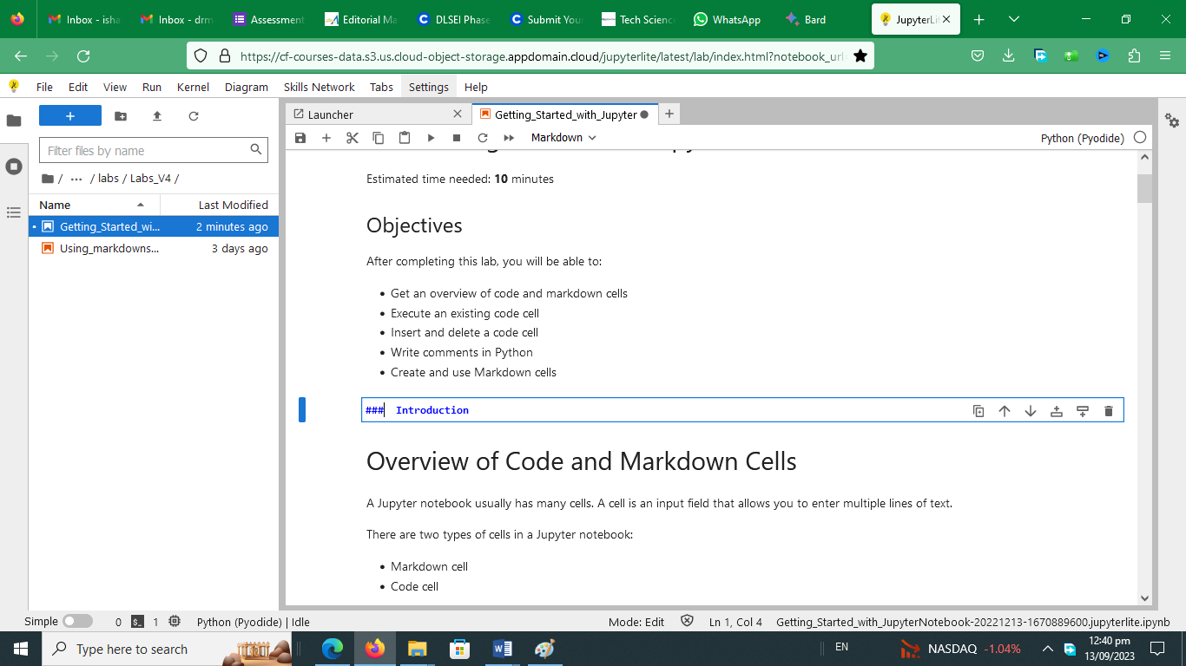

### Introduction

**Exercise 4 - Create a markdown cell to list data science languages. (3 pts)**

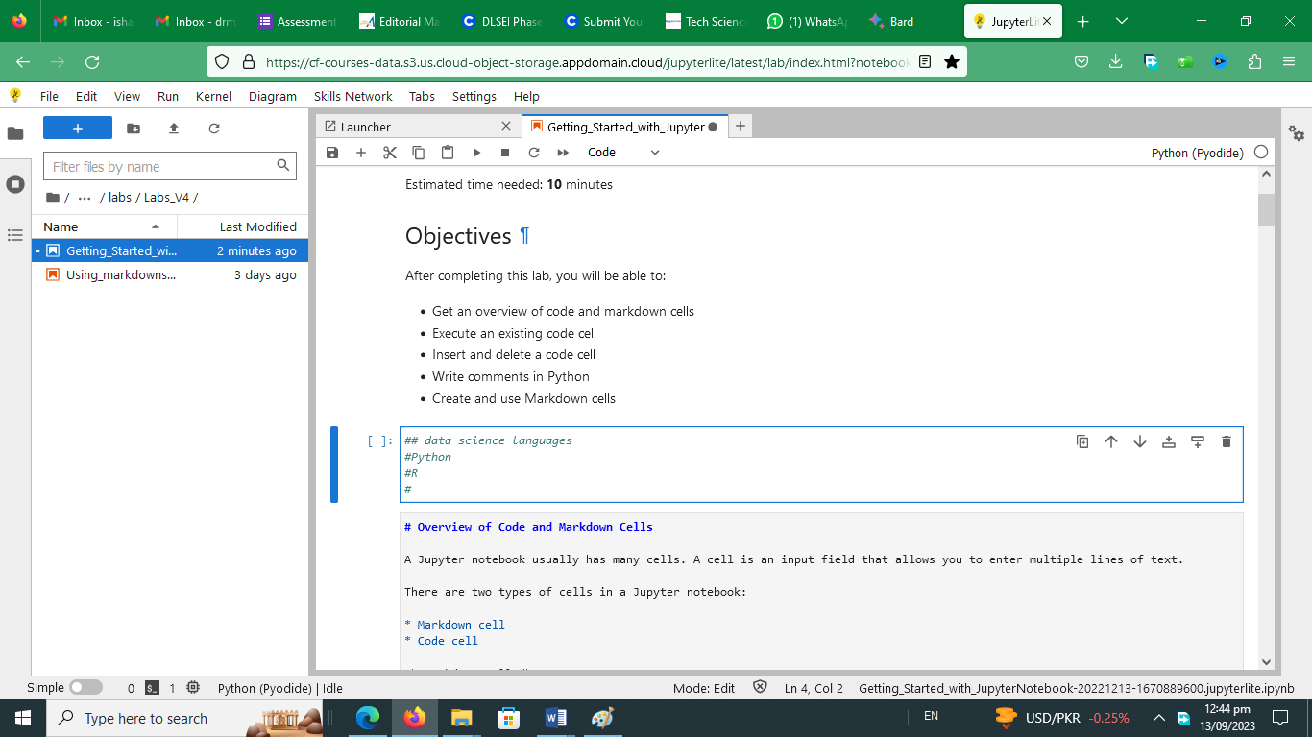

## data science languages

#Python #R #SQL

**Exercise 5 - Create a markdown cell to list data science libraries. (3 pts)**

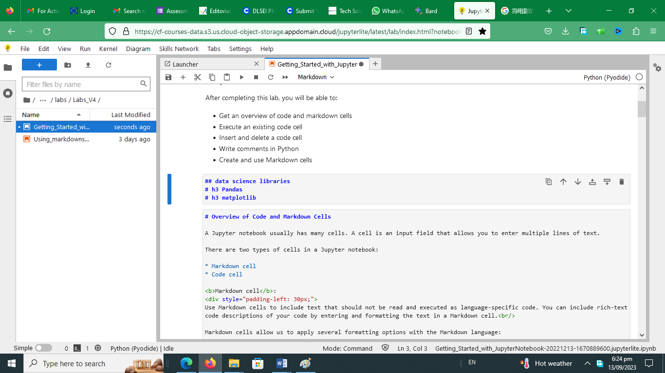

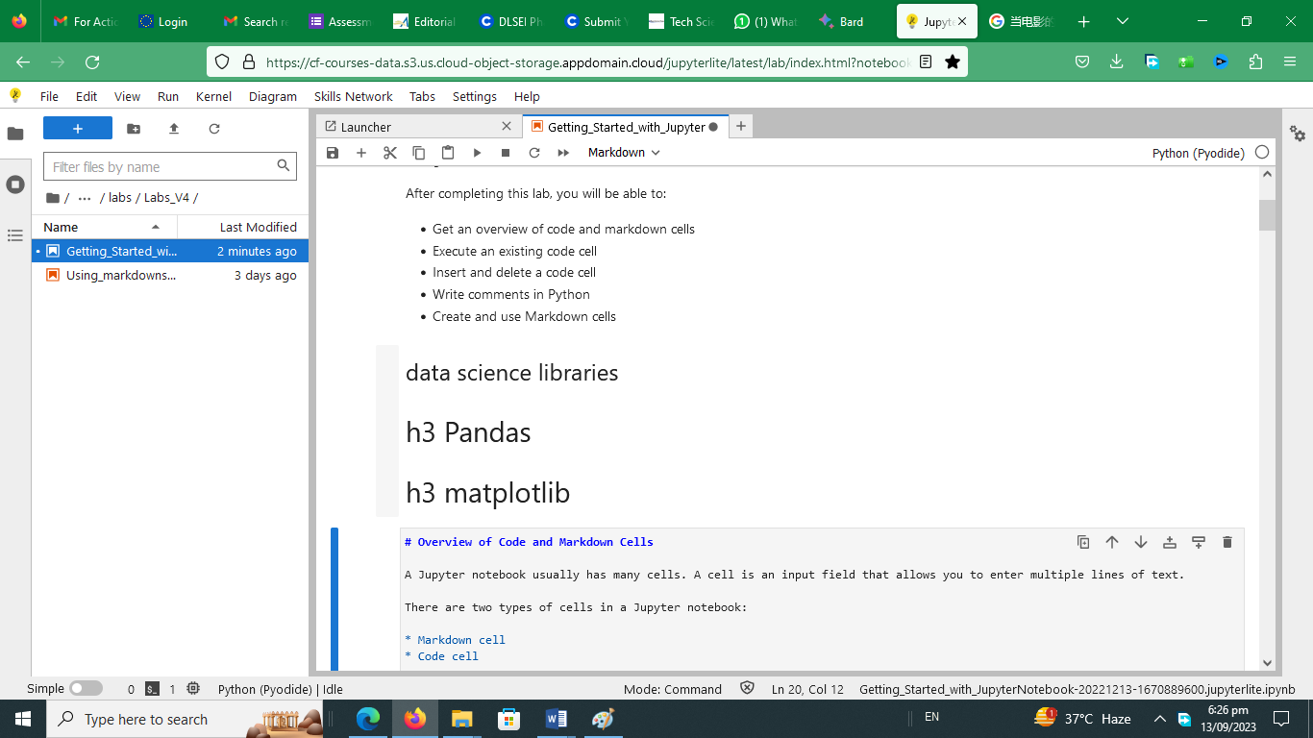

**Exercise 6 - Create a markdown cell with a table of Data Science tools. (3 pts)**

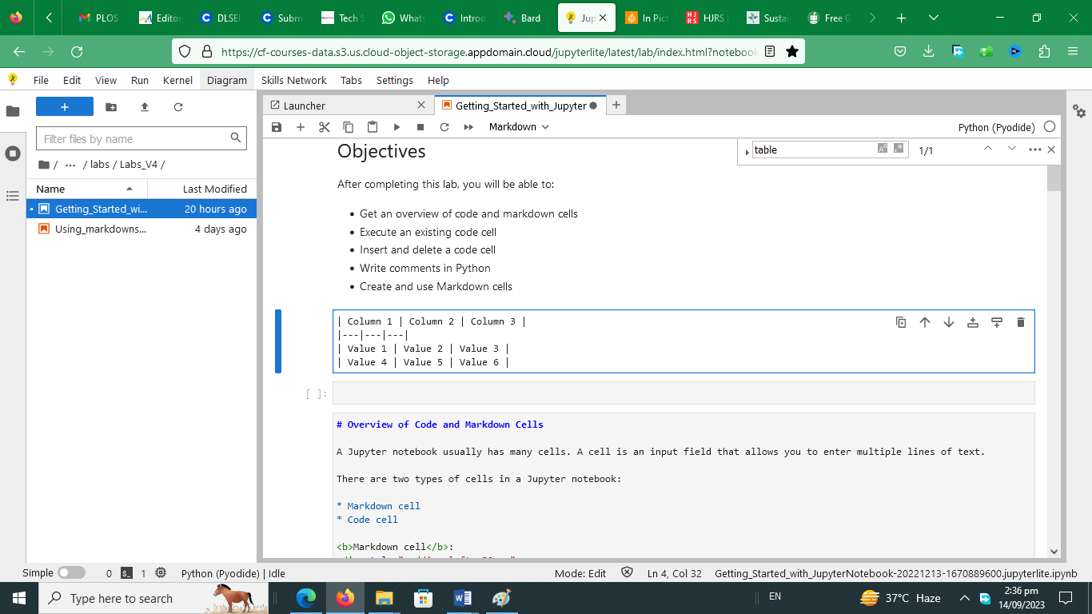

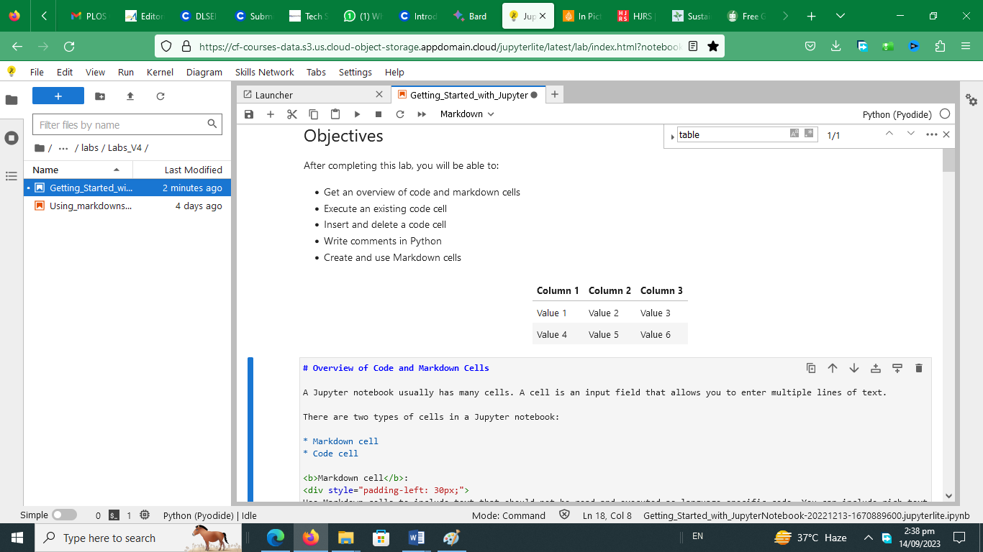

**Exercise 7 - Create a markdown cell introducing arithmetic expression examples. (1 pt)**



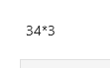

**Exercise 8 - Create a code cell to multiply and add numbers**. **(2 pts)**

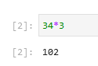

**Exercise 9 - Create a code cell to convert minutes to hours. (2 pts)**

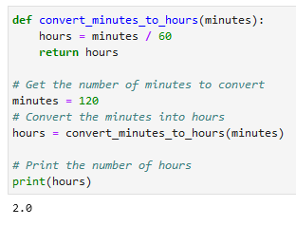

**Exercise 10 -Insert a markdown cell to list Objectives. (3 pts)**

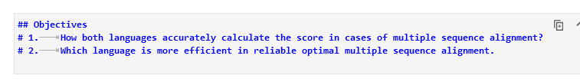

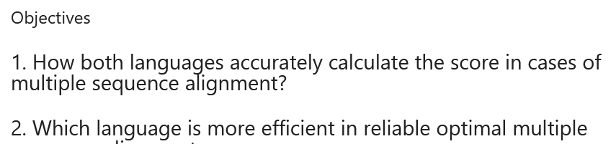

**Exercise 11 - Create a markdown cell to indicate the Author’s name. (2 pts)**

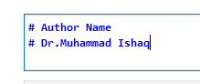

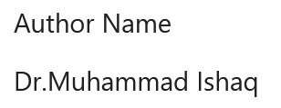

**Exercise 12 - Share your notebook through GitHub (3 pts)**

**Exercise 13 - Take a screenshot of the first page of the notebook. (1 pt)**

Exercise 2

**Exercise 5**